The dew point temperature Td can be calculated (approximately) from the relative humidity RH and the actual temperature T by
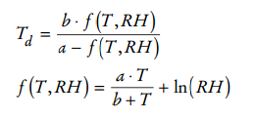

where a = 17.27 and b = 237.7° C.
Write a program that reads the relative humidity (between 0 and 1) and the temperature (in degrees C) and prints the dew point value. Use the C++ function log to compute the natural logarithm.

